**Falcon Heavy to launch NASA Psyche asteroid mission**

by [**Jeff Foust**](https://spacenews.com/author/jeff-foust/) — February 28, 2020

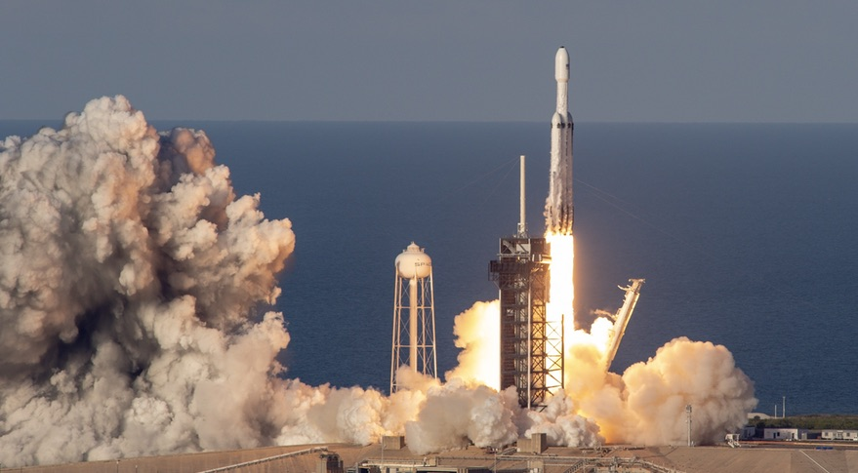NASA announced Feb. 28 it will use a Falcon Heavy to launch its Psyche asteroid mission in 2022. Credit: Craig Vander Galien

WASHINGTON — NASA awarded a contract to SpaceX Feb. 28 for the launch of a mission to a large metallic asteroid on the company’s Falcon Heavy rocket.

NASA said that it will use a Falcon Heavy to launch its Psyche mission in July 2022 from Launch Complex 39A at the Kennedy Space Center. The contract is valued at $117 million, which includes the launch itself and other mission-related costs.

Psyche is [one of two missions NASA selected in January 2017](https://spacenews.com/nasa-selects-two-asteroid-missions-for-discovery-program/) for its Discovery program of relatively low-cost planetary science missions. Psyche will use a Mars flyby in 2023 to arrive at its destination, an asteroid also called Psyche, in January 2026. The spacecraft will go into orbit around the asteroid, one of the largest in the main asteroid belt between Mars and Jupiter.

The asteroid is primarily made of iron and nickel, and could be the remnant of a core of a protoplanet that attempted to form there before high-speed collisions with other planetesimals broke it apart. Planetary scientists believe that studies of the asteroid Psyche could help them better understand the formation of the solar system.

The Psyche mission is led by Arizona State University, with Maxar the prime contractor for the spacecraft. The launch will also carry two smallsat secondary payloads: Escape and Plasma Acceleration and Dynamics Explorers (EscaPADE), which will study the Martian atmosphere, and Janus, which will study binary asteroids.

The other mission selected for the Discovery program in 2017, Lucy, will visit Trojan asteroids in the same orbit around the sun as Jupiter. [NASA awarded a launch contract to United Launch Alliance](https://spacenews.com/ula-wins-competition-to-launch-nasa-mission/) in January 2019 for the launch of that mission on an Atlas 5 in October 2021.

SpaceX subsequently [filed a protest with the Government Accountability Office](https://spacenews.com/spacex-protests-nasa-launch-contract-award/) over that award, arguing that it could have launched the mission for significantly less than the $148.3 million value of the ULA contract. ULA argued that it provided schedule assurance needed for a mission that must launch in a 20-day window. SpaceX [dropped the protest in April 2019](https://spacenews.com/spacex-drops-protest-of-nasa-launch-contract/), nearly two months after it was filed.

Since them, though, SpaceX has enjoyed success winning NASA launch contracts. Within a week of dropping the GAO protest, [SpaceX won a contract for the launch of the Double Asteroid Redirect Test (DART) spacecraft](https://spacenews.com/nasa-awards-dart-launch-contract-to-spacex/) on a Falcon 9. That mission, launching in June 2021, will send a spacecraft to the near Earth asteroid Didymos, deliberately colliding with a small moon orbiting that asteroid to test deflection techniques for planetary defense.

In July 2019, [NASA won a contract for the launch of NASA’s Imaging X-Ray Polarimetry Explorer (IXPE) astrophysics mission](https://spacenews.com/spacex-wins-contract-to-launch-nasa-small-astrophysics-mission/), scheduled for launch on a Falcon 9 in April 2021. That spacecraft was baselined for launch on a much smaller Pegasus rocket from Northrop Grumman, but SpaceX won the contract at a price lower than previous Pegasus missions.

NASA [awarded SpaceX a contract Feb. 4 for the launch of its Plankton, Aerosol, Cloud, ocean Ecosystem (PACE) Earth science mission](https://spacenews.com/spacex-wins-nasa-contract-to-launch-earth-science-mission/) on a Falcon 9 in December 2022. NASA awarded that contract despite, less than a week later, stating in its fiscal year 2021 budget proposal it would seek to cancel the mission. PACE had been proposed for cancellation in the previous three years’ budget requests, and each time Congress rejected the cancellation and funded the mission.

Psyche is NASA’s first mission to use SpaceX’s Falcon Heavy rocket as the primary customer, although some NASA payloads flew on the Falcon Heavy STP-2 mission for the Defense Department’s Space Test Program in June 2019. SpaceX’s current manifest for the heavy-lift rocket includes two classified missions for the U.S. Air Force in late 2020 and early 2021 and a ViaSat-3 broadband communications satellite for Viasat in mid-2021.

Source: <https://spacenews.com/falcon-heavy-to-launch-nasa-psyche-asteroid-mission/>

Summary:

NASA has selected SpaceX to launch the Psyche asteroid mission in July of 2022. The Psyche asteroid mission will study one of the largest asteroids in the main asteroid belt between Mars and Jupiter called Psyche. This asteroid is made primarily from Iron and Nickle and could be the remnant of a core of a protoplanet that was in the process of formation before high speed collisions broke it apart. “The Psyche mission is led by Arizona State University, with Maxar the prime contractor for the spacecraft. The launch will also carry two smallsat secondary payloads: Escape and Plasma Acceleration and Dynamics Explorers (EscaPADE), which will study the Martian atmosphere, and Janus, which will study binary asteroids.” Psyche is important to SpaceX as it is NASA’s first mission to use the Falcon Heavy as the primary customer.